

The Standard for

Travertine Paver

Quality Level Assessment

**GSI Quality Levels**

**Level 1 -** Plus

**Level 2** - Premium/Select

**Level 3 -** Classic

**Common Industry Quality Level Terminology**

A variety of terms are commonly utilized to classify the various quality levels of natural stone pavers. These terms are utilized without any qualifying data. Some of the terms commonly used without include:

Plus

Premium

Select

Standard

Commercial

Builder Grade

Unless these terms are accompanied by a defined assessment level such as GSI the terms are meaningless.

**Range**

Specification range is equivalent to 90% total volume.

**Determining Factors**

1 – Color Variation

Variation in color is inherent in all types of natural stones. The degree in which the color varies is what determines the quality level of the travertine paver.

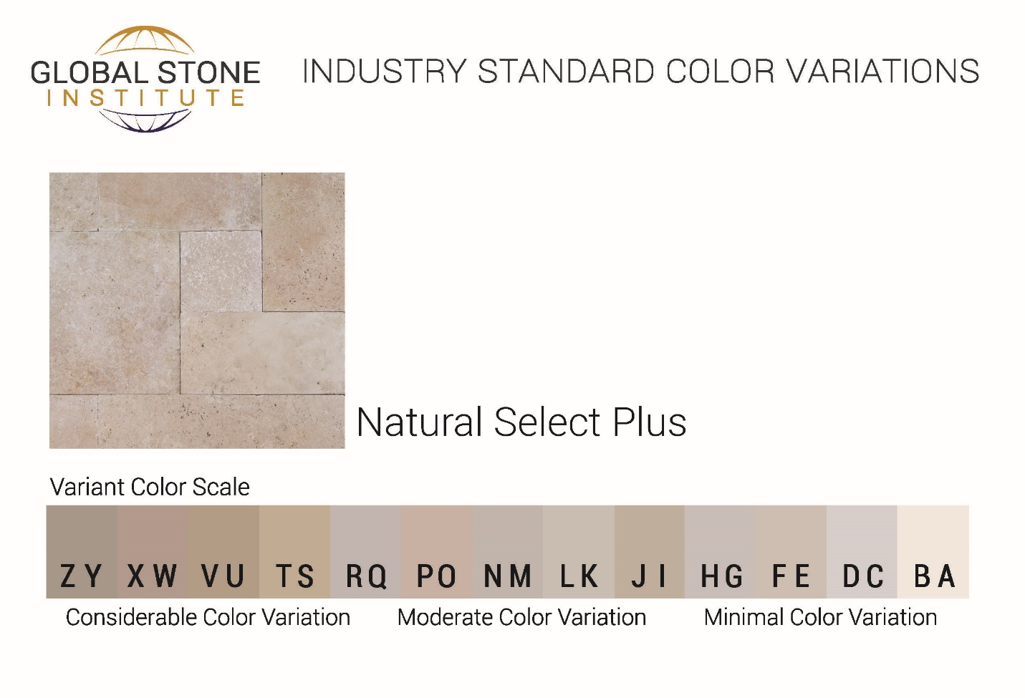

**Level 1 -** Plus

Minimal Color Variation – Variation ranging from A - F

**Level 2 –** Premium/Select

Moderate Color Variation - Variation ranging from A - N

**Level 3 -** Classic

Considerable Color Variation – Variation ranging from A - Z

2 – Pitting

**Level 1 -** Plus

Pitting no larger than 1/8”

Total pitting less than 5%-10% total surface area

**Level 2 –** Premium/Select

Pitting no larger than 3/8”

Total pitting less than 10%-20% total surface area

**Level 3** **-** Classic

Pitting no larger than 3/4”

Total pitting less than 20%-40% total surface area

3 – Thickness & Dimensions

**Level 1 -** Plus

Variation no greater than 1/16”

**Level 2 –** Premium/Select

Variation no greater than 2/16”

**Level 3** **-** Classic

Variation no greater than 3/16”